COPYRIGHT QUOTATION
Dated: 08/07/2025
~ To Whomsoever it May Concern ~
Quotation Prepared by: Adv. Pranav Bhat
Contact Details: 9035685434
Email: an.astraea@gmail.com / pranavbhat334@gmail.com
Service | Item | Official Fee | Fee | Total
Copyright filing | Copyright filing at CRO | 500 | 7500 | 8000
Copyright Prosecution | Filing response to objection | - | 5000 | 8000
Copyright Prosecution | Attending for Hearing and  filing written submission | - | 8000 | 8000
Notes:
- In case a similar quotation is required again, kindly reach out to us, and we will be happy to assist you.
- GST is Exclusive of this quotation.
- Payment shall be made stage wise, and if the mark is granted without going to next stage, payment for further stages is not necessary. Stamp duty, notary, and bank charges will be communicated separately.
Should you have any questions or require further clarification, please feel free to contact us at the provided email or phone number.
Thank you for considering our services. We look forward to assisting you with your intellectual property needs.
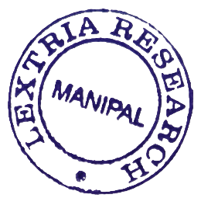
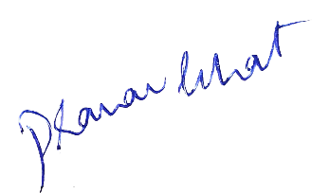

Best Regards,
Adv. Pranav Bhat
Chief IP Strategist
Lextria Research

